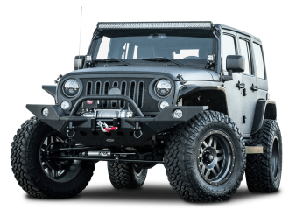

Let’s go for a ride!

**Car Parts**

Rearview mirror

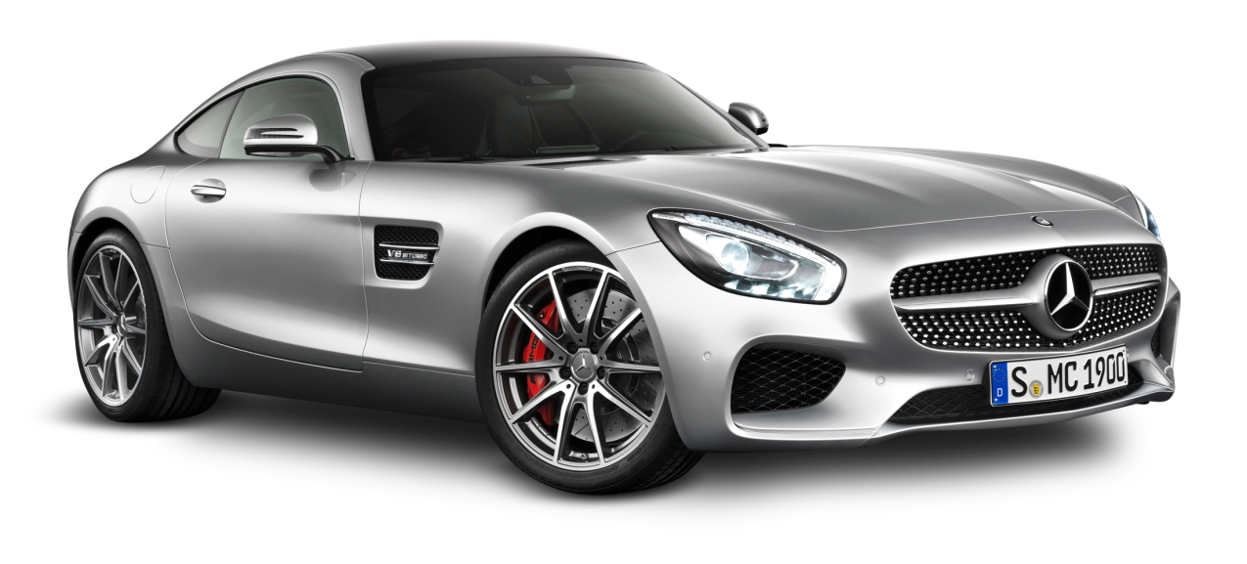

Windshield / Windscreen

Door handle

Hood

Wing mirror

Driver’s license

License plate

Headlight

Bumper

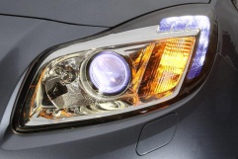

Blinker / Indicator

Windshield wiper

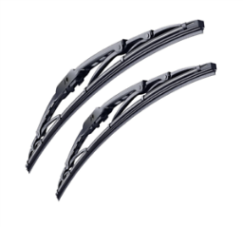

Seat belt

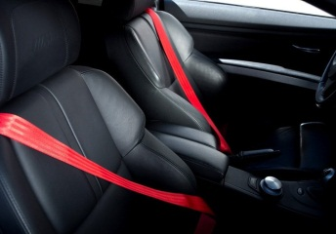

Seat

Wheel

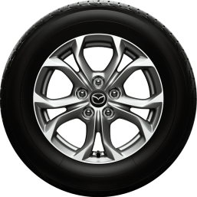

Tire

Engine

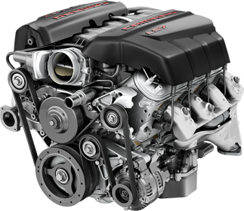

Accelerator / Gas pedal

Brake

Clutch

Horn

Steering wheel

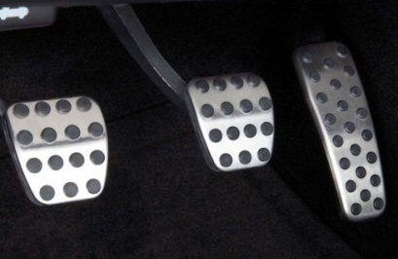

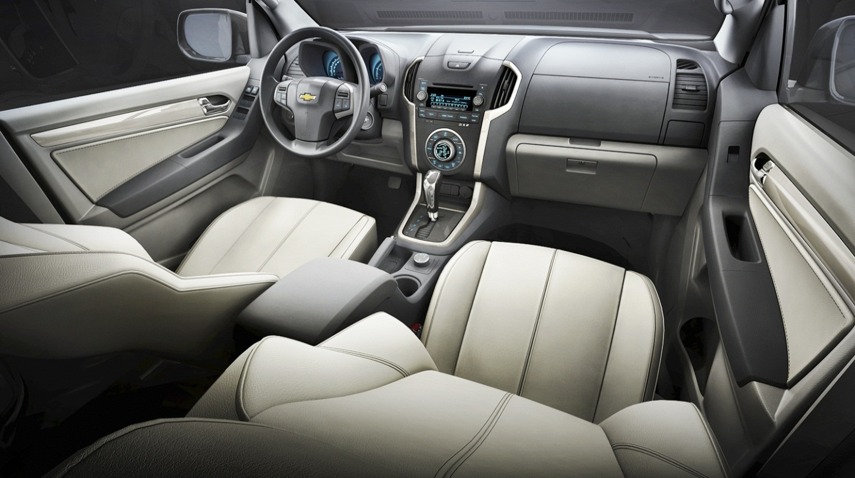

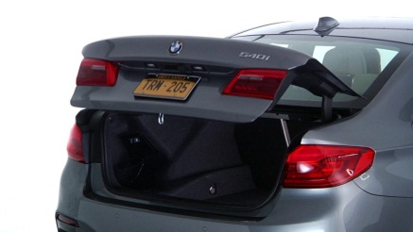

Tail lights

Trunk

Glove compartment

Gear

Glove compartment

Brake

Engine

Gear

Wheel

Accelerator

Windshield wiper

Seat

Horn

Steering wheel

Clutch

Tire

Windshield

Hood

Seat belt

Tail lights

Trunk

Blinker / Indicator



Door handle

Rearview mirror

Wing mirror

License plate

Bumper

Headlight

